Campus Attendance System

Project Documentation – Assignment 2

1. Project Introduction
1.1 Background & Connection to Assignment 1
This project is a functional implementation of the prototype completed for Assignment 1. The overall theme, page structure, and core functions remain consistent with the original design. Only necessary improvements are added to meet the requirements of Assignment 2.
1.2 Expected Functions
- User login with basic validation
- Check-in and check-out with real-time recording
- Attendance history display using data binding
- GPS location access (new for Assignment 2)
- Stable navigation between pages
- Run smoothly on Windows using .NET MAUI

2. Requirement Analysis & Solutions
Requirement | Solution Implemented
User login and access control | Login page with empty input validation
Record check-in/check-out time | Real-time clock on the attendance page
View attendance history | CollectionView with data binding
Native device hardware access | Obtain GPS location during check-in/out
Stable multi-platform running | Target Windows framework in .NET 9
Clean and usable interface | Consistent layout and color scheme

3. Changes from Assignment 1 Prototype
This project follows the original prototype from Assignment 1 with justified improvements:
- Added GPS location recording to meet native device access requirements.
- Used data binding for the attendance record list.
- Improved page navigation using MAUI Shell.
- Standardized project structure by organizing pages into a Pages folder.
- Unified page naming and corrected route matching: Renamed the attendance page from CheckInPage to CheckPage to ensure consistency with file structure, namespace, and Shell navigation, eliminating page resolution failures.
- Implemented local JSON file storage: Added FileManager and AttendanceRecord model to achieve persistent data storage, so attendance records are saved locally and remain available after restarting the application.
- Replaced obsolete UI controls: Changed deprecated Frame to Border in the record page to remove warning messages and improve compatibility with .NET 9.
- Fixed outdated code in App.xaml.cs: Adopted the recommended CreateWindow pattern instead of the obsolete MainPage assignment to meet .NET MAUI standards.
All changes are necessary to meet the marking criteria of Assignment 2 and do not change the original purpose of the system.

4. UI Prototype & Implementation Description
The app keeps the three-page structure from Assignment 1:
Login Page
- Title: Campus Attendance System
- Input fields for Student ID and Password
- Sign In button with validation
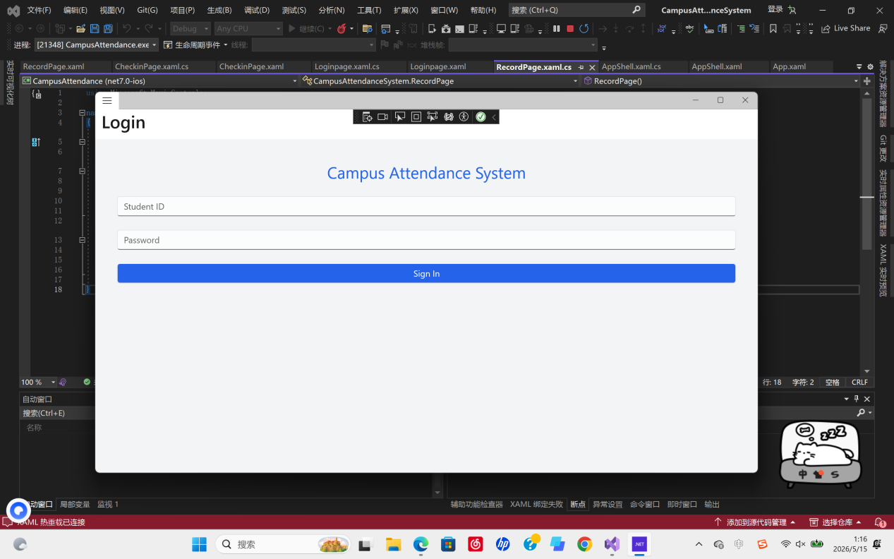

Check Page
- Real-time display of current date and time
- Check In, Check Out, View Records buttons
- GPS location automatically obtained (new in Assignment 2)
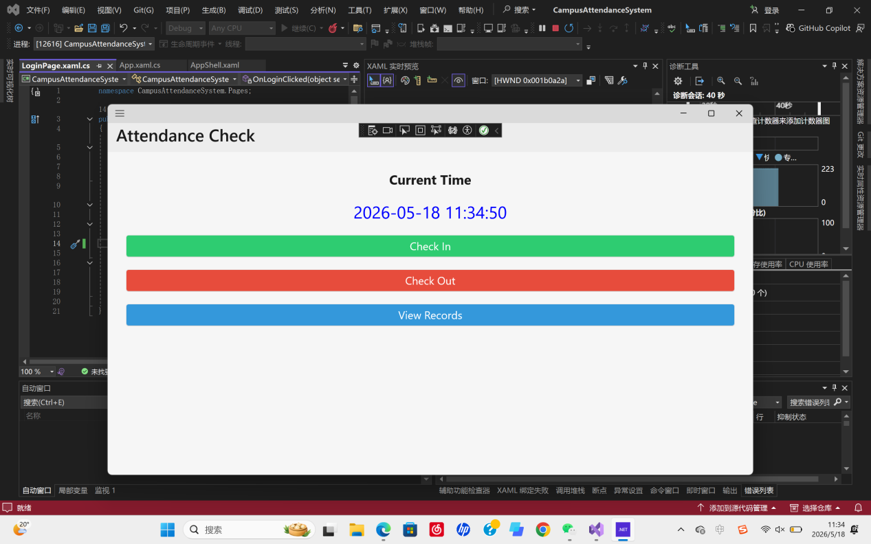

Records Page
- Show all historical check-in/check-out entries
- Scrollable list using data binding
- Back button to return to the main page
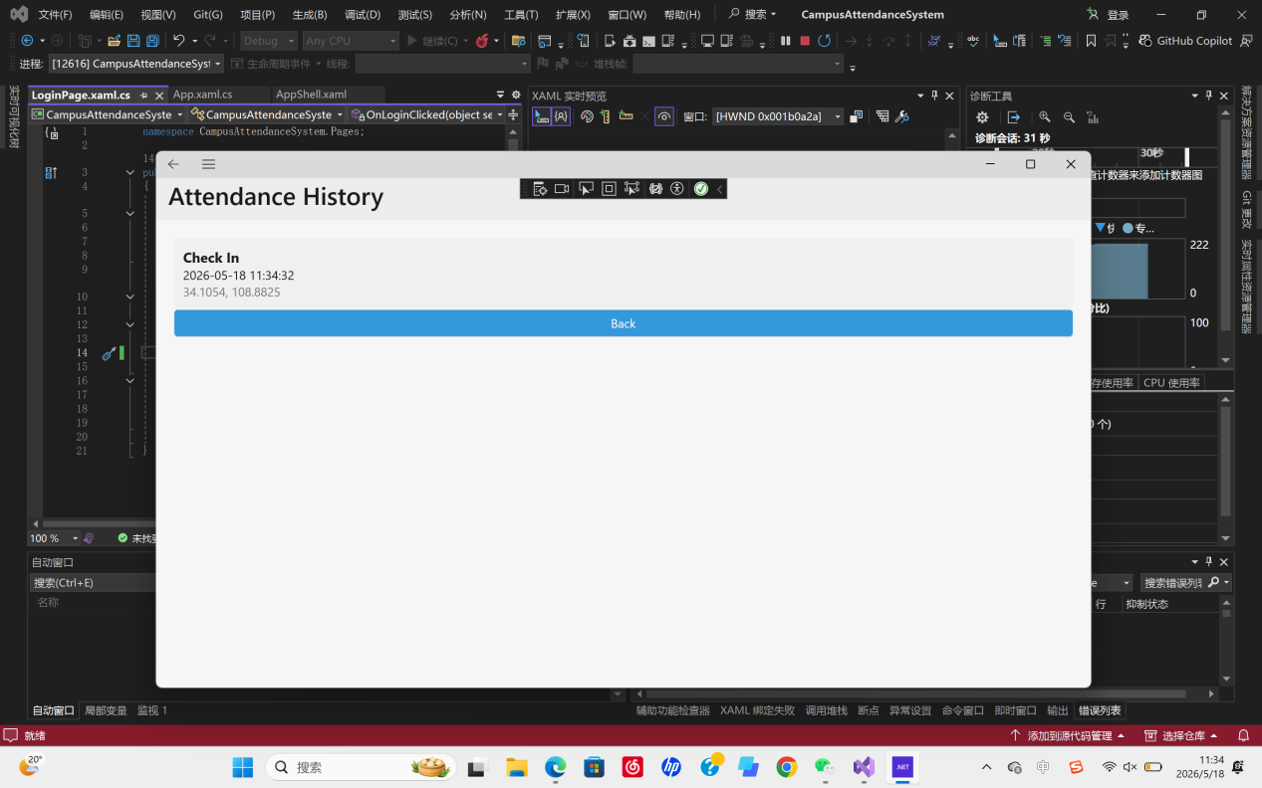

5. Project Challenges & Solutions
5.1 Challenges Solved
- InitializeComponent() error: Cleaned bin/obj folders and fixed namespace consistency.
- Navigation failure: Used MAUI Shell routing to manage page transitions.
- GPS unavailable: Enabled location permission in package manifest.
- Environment compatibility: Switched to the correct Windows target framework.
- Cannot resolve type / XLS0414 / XC0000 errors: Reloaded the project, cleaned Visual Studio cache, and ensured consistent class names, file names, and namespaces across CheckPage, RecordPage, and AppShell.
- Route matching failure: Corrected inconsistent page naming and updated navigation routes to ensure stable login-to-attendance navigation.
- Obsolete control and code warnings: Replaced Frame with Border and updated App.xaml.cs structure to eliminate warnings.
5.2 Unresolved Issues & Reasons
No user role differentiation (teacher/student).
Reason: Limited by time and assignment scope.
5.3 Reflection
This project is developed based on the Assignment 1 prototype. During the implementation, I gained practical experience in .NET MAUI UI layout, navigation, data binding, native device access, and data persistence using local file storage. I also understood the importance of stable development environment, project structure management, namespace consistency, and Shell route configuration. The project successfully meets all requirements of Assignment 2, including stable running, data persistence, UI compatibility, and native hardware access.

6. Debugging and Testing Process
During development, we encountered environment-related errors. We resolved these issues by reinstalling the latest version of Visual Studio 2022 and using .NET 9.0 for the project. We also adjusted the target framework to ensure the application runs smoothly and stably on Windows.
We tested all functions step by step, including login validation, button events, page navigation, GPS location retrieval, and attendance record display. All features work correctly after environment optimization and framework configuration.

7. Team Profile & Roles
Name | Role | Responsibility
Meng Chengzhen | Project Manager | Project coordination, documentation, submission
Wang Guoxin | Business Analyst  Developer | Requirement analysis, prototype design, GitHub management  Code implementation, navigation, GPS function, debugging
Pan Yuening | UI Designer | Interface layout, style design, prototype improvement

8. Conclusion
This Campus Attendance System is a complete implementation based on the Assignment 1 prototype. It satisfies all Assignment 2 requirements, including multi-page navigation, data binding, UI consistency, native GPS location access, and local data persistence using JSON file storage. The app runs stably on Windows with zero build errors and zero warnings, and can be further extended with user authentication and backend services in the future.

9.Source Control (GitHub)
We used GitHub as the source control platform. The project repository is:
https://github.com/Wangguoxin630/CampusAttendanceSystem
Lecturer Bede Amarasekara has been added as a collaborator to allow full access to the code and commit history.

